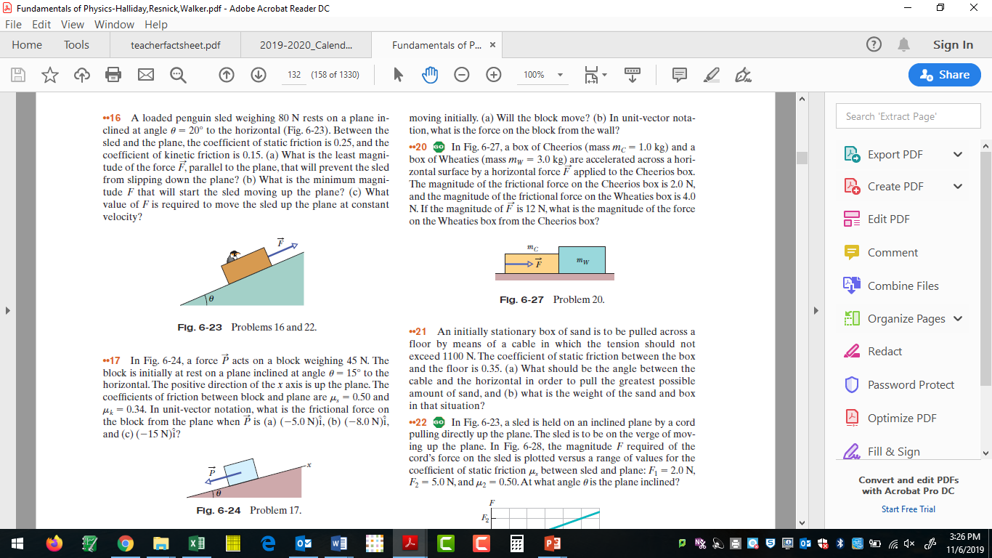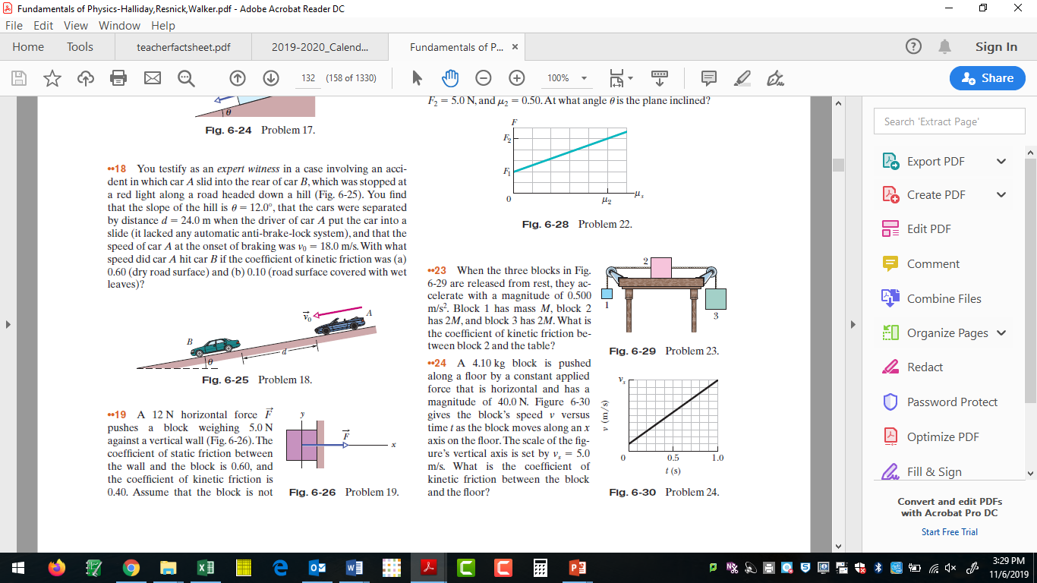

Answers Only. Detailed answers to follow.

**16.** (a) 8.6 N ; (b) 46.16 N ; (c) 38.6 N

**17.** (a) 17 N ; (b) 20 N ; (c) 15 N

**18.** (a) 12.1 m/s ; (b) 19.4 m/s

**19.** (a) no; (b) - 12 N + 5.0 N

**20.** 8.5 N

**21.** (a) 19°; (b) 3.3 kN

**22.** 18.4

**23.** 0.37